In my project, I am planning to create a program for my friend so he can use it to calculate the salary for his restaurant. Hence, I am using Pandas and Numpy as my main library and some other libraries to support the program.

First, I need to solve the duplicate data from the check-in/out excel. There are multiple check-ins and check-out data from an employee on the same day; this will make my program confused because it can’t identify the correct working time, so it’s not able to count the late minutes for each employee.

Hence, I found a drop function in Pandas so that I can filter by specific columns then drop the duplicates based on selections. I filter by employee name, data, and status (check-in or out), then I keep the first record because that is the first successful record for the check-in/out data. 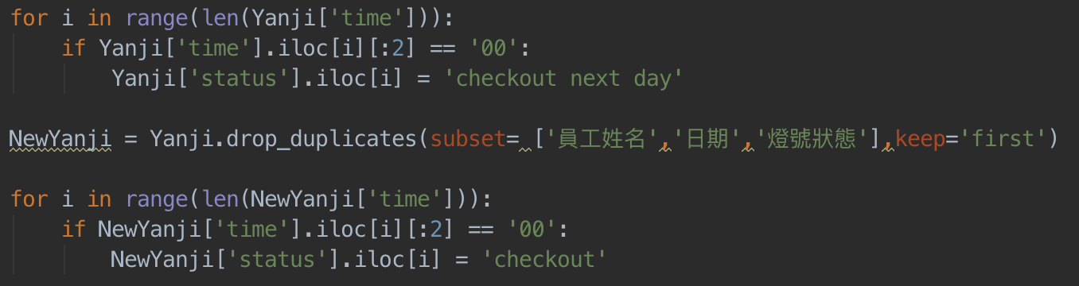

However, later I found out there are some employees will work until midnight then check out on next day. If this employee also has to work on that day, there will be one check-out data be deleted. So, replace the status if the check-out time starts with 00:xx:xx, and then change it back to original one after remove all the duplicates.

After this part completed, I started reading all the excel files and make all of them to the dictionary for the future use. For example, I read the excel file and build the base pay dictionary, working time table dictionary. When all the dictionaries are completed, I joined them together, so I found the late minutes for each employee and calculate their bonus.

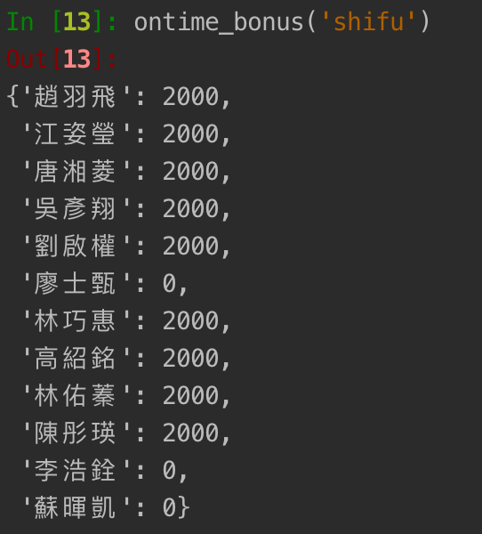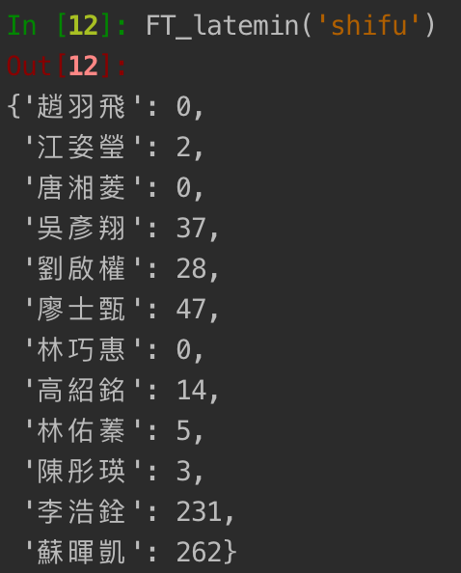

The third step was calculating how many hours that part-time employee works each day. The challenge was I caused by employees didn’t check-in/out correctly. The missing data will cause the program errors because I was selecting check-in and check-out together. If there is any of the check-in/out missing, the program is not going to generate correctly. Hence, I have to create a fake data to make the working hour 0, as a punishment for employee forgot to check-in. Next, my friend’s restaurant is offering daily bonus for employees if the revenue hits the goal. This part wasn’t as difficult as previous part. I end up finished the program in a day.

Last but not least, I have to join all the data then export to the excel sheet. I wrote four functions to join the data because of the way that organized full-time employees, and part-time employees were different. After the program completed, I can generate an excel file with all the data correctly for my friends. If he was calculating all this information by himself, he needs a couple of hours to do it, but now I can get the data in 5 minutes.

Throughout the project, I am satisfied with my work because I build a project by myself. Although I had a lot of difficulties at the beginning, I overcome every challenge. I will keep updating the code to make it better and better.